**Project title: Ozone3 Studio**

**Table of Contents**

Table of Contents…………………………………….…..2

1. 0 Introduction………………...…………………..……3
2. 0. Project Pages……….……………………………….4
3. 1. Home page……….……………….…………...…….4
4. 2. About Us page ……….……………………..……….5
5. 3. Our Works page ……….………….………..……….6
6. 2. Contact From page ……….…………….…..……….7

**Introduction**

* The purpose of this documentation is to provide a comprehensive overview of the Ozone3 Studio web application. The document aims to explain how the project is implemented and provide a brief understanding of the application's features and functionalities. This documentation serves as a guide for developers who are interested in understanding the technologies used in building the application. It also aims to provide a reference for stakeholders who want to learn more about the Ozone3 Studio platform and its capabilities.
* Ozone3 Studio is a web application built using the ReactJs that provides a platform for recording, singing, and acting in a studio. The application has 6 pages: Home, About Us, Our Works, Contact Form, Sign In, and Sign Up. In this document, we will discuss the features and functionality of each of these pages. The web app is also fully responsive for all mobile devices that can view the web app full clear.

**Project Pages**

1. Home Page

* The home page of Ozone3 Studio welcomes users to the platform and provides an overview of the services offered by the studio. The page includes a navbar menu that allows users to navigate to other pages of the application. The home page also includes two buttons that contain the link for the Instagram and the TikTok pages.

1. About Us Page

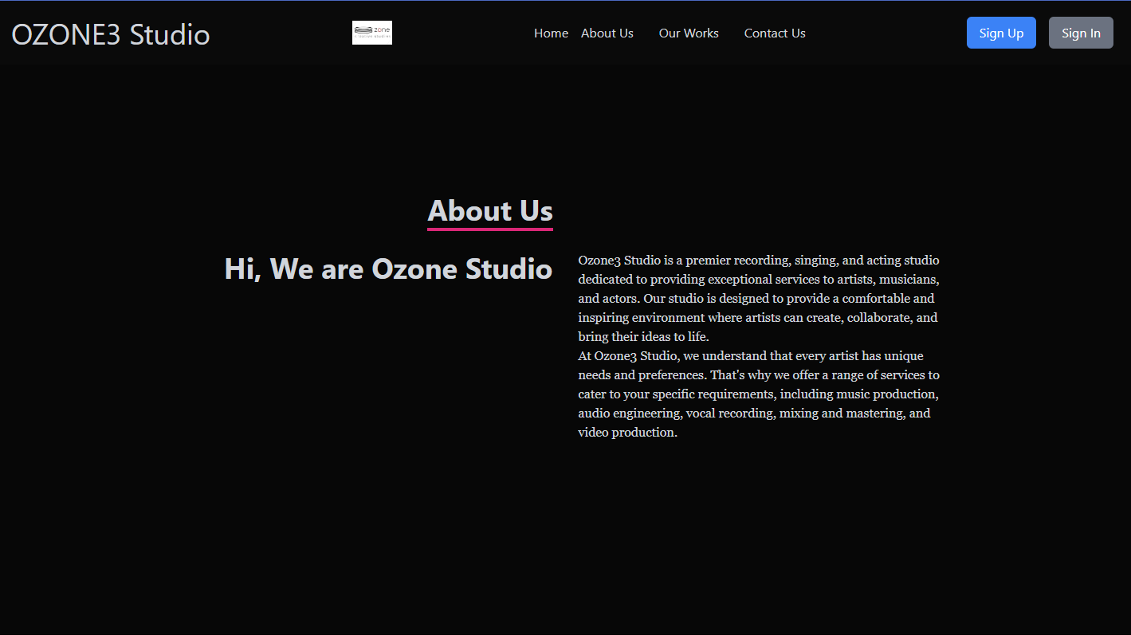

* The About Us page provides information about the Ozone3 Studio team and their mission. The page also includes a section that provides information about the studio's history and its mission.

1. Our Works Page

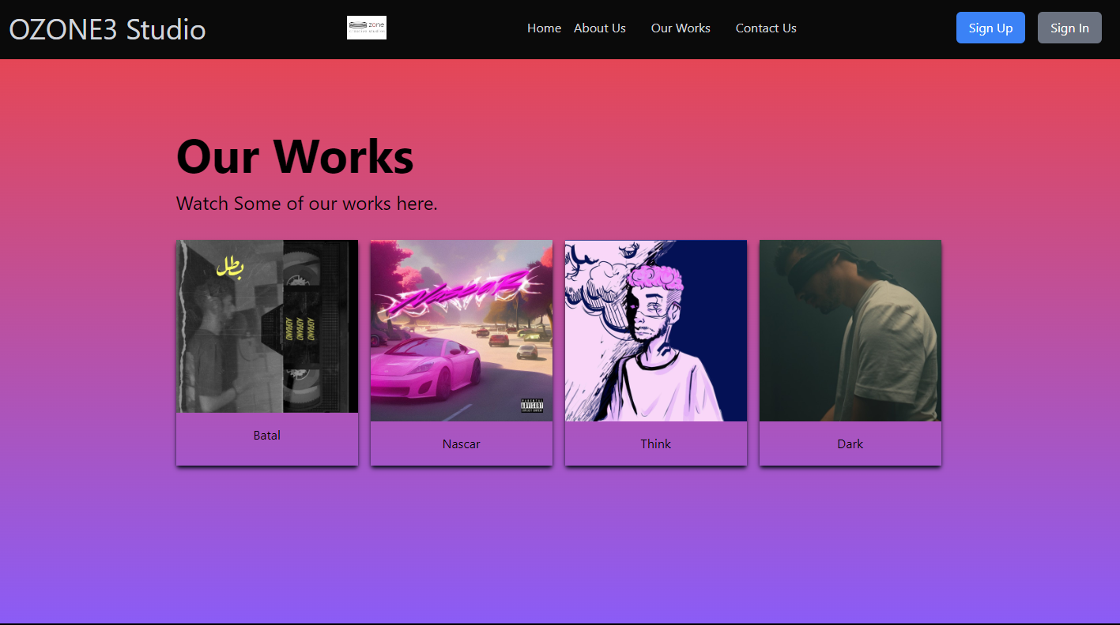

* The Our Works page displays the studio's portfolio of work. The page includes a gallery of images showcasing the studio's past projects. The images have a hovering style when the user moves on them.

1. Contact Form Page

* The Contact Form page provides users with a way to get in touch with the Ozone3 Studio team. The page includes a form that users can fill out to send a message to the studio. The form includes fields for the user's name, email address, and message.